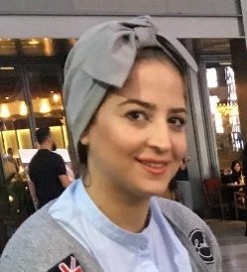

Sara Saad

+971 (55) 677-9773

saralawyer88@gmail.com

### Experience

04/2017 to Now

**LAWYER**

**Al ZAROONI Group of Companies**, Dubai

* Register and maintain legal cases in RDC
* Assisting to prepare a client’s case documents.
* Follow-up bounced Cheque
* Execute Law enforcement of evacuations

04/2015 to 04/2017

**LEGAL RESEARCHER**

**YOUSIF AL-SHARIF & CO**, Dubai

* Register and maintain legal cases in Dubai court System
* Register and maintain cases in Real Estate Regulatory Agency (RERA)
* Following cases in Dubai municipality
* Assisting to prepare a client’s case documents.
* Reserve appointments for clients’ case in Dubai court
* Contribute to the preparation of the Dr. Yusuf al-Sharif's radio program.

09/2014 to 09/2015

**TRAINEE ADVISOR**

**AL MAARAF LAW CENTRE,** Dubai

* Assisting to prepare a client’s case documents.
* Reserve appointments for clients’ case in Dubai court
* Attending legal defense in court with lawyer
* Undertaking legal research.

06/2012 to 06/2013

**TRAINEE ADVISOR**

**ALI IBRAHIM LEGAL CONSULTANTS,** Dubai

* Assisting to prepare a Real estate case documents.
* Registration and follow-up cases and issues in the municipal committee dispute rentals

**LAWYER**Equipped with extensive experience in Legal action and UAE Rental Law. Employs excellent leadership skills and multi-tasking strengths. Demonstrated ability to improve Legal Procedure.

### Education

BACHELOR OF LAW 2005 - 2010

TISHREEN UNIVERSITY, Syria

### Skills

* Computer: Windows & Microsoft office
* Internet: Very Good
* Arabic: Expert
* English: Very good
* Knowledge in UAE labour law office ,Municipality Procedures
* UAE driving license